|  |  |
| --- | --- |
| **Reg. #** |  |
| **Marks** |  |

**EXPERIMENT # 5**

**Harmonics and Fourier Series**

**Objective:**

The objective may be to have a hands-on experience of harmonic analysis.

**Equipment**

* Lucas Nulle Interface and Experimenters connected to a PC with Labsoft
* Lucas Nulle Power Electronics 1 (SO4203-4D , RLC load Card)
* Digital Oscilloscope with probe
* Connecting wires for Lucas Nulle Equipment

**Fourier Series of Input Current of a Full Wave Rectifier with Inductive Load**

Set up the circuit of a single phase diode based rectifier on Lucas Nulle equipment. A schematic diagram of the rectifier system is shown in Fig. 1. RM1, RM2 and RM3 are 1Ω resistances for observation of current waveform. The Lucas Nulle equipment picture for such a system is presented in Fig. 2.

----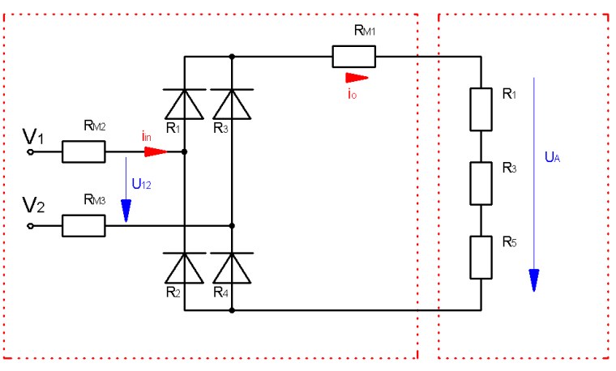

Figure. 1

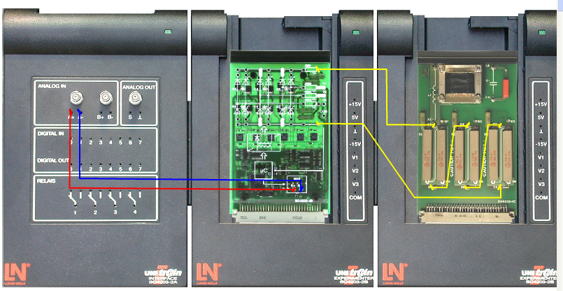

Figure. 2

Select the Timing Diagram Tool from Labsoft. Go to Settings 🡪 Parameters and adjust according to Fig. 3.

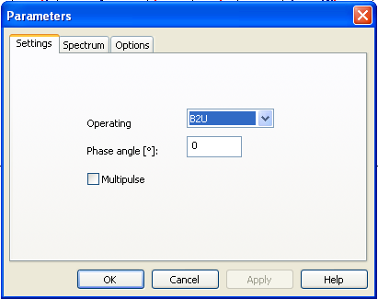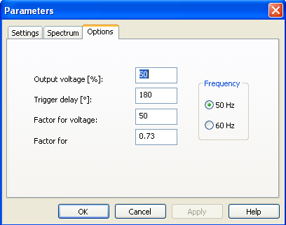

Figure. 3

Double click on the Timing Diagram and select the signals to be viewed as well as their colors. Select input voltage (Red), input current (Blue) and output voltage (Green). Then start the measurement by pressing C:\Program Files\LUCAS-NÜLLE\L@BSOFT\BooksENU\1E02\MTI42\images\RunStop.gif in the tool bar. Sketch your results on the graph portion in Fig. 4.

View the output voltage waveform on a standard lab oscilloscope and show this to the instructor. Now proceed towards Fourier Analysis. Select FFT in Labsoft. Again go to Settings 🡪 Parameters and select input voltage in the Spectrum Menu as shown in Fig. 5.

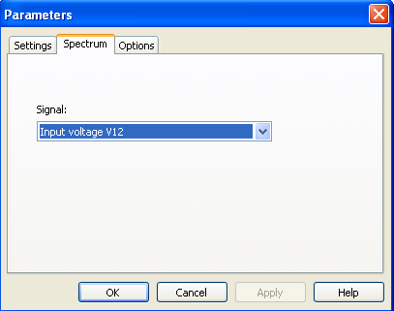

Figure. 5

View the spectrum of the input voltage. This should mainly consist of a single bar at 50Hz. Then select the output voltage as the signal and again view the Fourier spectrum. Sketch the output voltage and its spectrum (with proper Y-axis values) on Fig. 6.

Figure. 6

|  |  |
| --- | --- |
|  | Calculation |
| DC Component |  |
| Second Harmonic |  |
| Fourth Harmonic |  |
| Sixth Harmonic |  |

Use the Digital oscilloscope for the following. Use ‘Measure’ function to measure the average and rms values of full wave rectified output voltage.

$$V_{RMS}=\frac{V_{P}}{√2}$$

$$V_{AVG}=\frac{{2V}_{P}}{π}$$

|  |  |  |
| --- | --- | --- |
|  | Calculation | Observed Values |
| Peak Value |  |  |
| Average Value |  |  |
| Rms  Value |  |  |

Now change the load to purely inductive load. Use the 200mH inductor available on Lucas Nulle load card. In Labsoft, go to Settings 🡪 Parameters and adjust the output voltage to 75%. Double click on the Timing Diagram and select the signals to be viewed as well as their colors. Select input voltage (Red), input current (Blue) and *output current* (Green). Observe these waveforms and sketch in Fig. 7.

Perform Fourier Analysis of the input current signal and sketch the current and its spectrum (with proper Y-axis values) on Fig. 8.

Figure. 8

|  |  |  |
| --- | --- | --- |
|  | Calculation | Observed Values |
| DC Component |  |
| Fundamental |  |
| Third Harmonic |  |
| Fifth Harmonic |  |
| Seventh Harmonic |  |

|  |
| --- |
| **Write a detailed note on what you have learnt from this lab exercise.**  **________________________________________________________________________________________________________________________________________________________________________________________________________________________________________________________________________________________________________________________________________________________________________________________________________________________________________________________________________________________________________________________________________________________________________________** |